**LAB # 03**



**DBMS LAB**

Submitted by: **Maaz Habib**

Registration No: **20PWCSE1952**

Class Section: **C**

“On my honor, as a student of University of Engineering and Technology, I have neither given nor received unauthorized assistance on this academic work.”

Submitted to:

**Engr. Sumayyea Salahuddin**

Wednesday, March 15th, 2023

**Department of Computer Systems Engineering**

**University of Engineering and Technology, Peshawar**

Lab # 03: Improved Web Design using CSS/Bootstrap

OBJECTIVES OF THE LAB

------------------------------------------------------------------------------------------------------------ This lab aims at the understanding of:

* The concept of Dynamic HTML
* Cascaded Style Sheets (CSS)
* Various attributes of CSS such as font, color, background, text, border, margin, and list
* User-Defined Selectors including Class and ID
* Span and Div Tags
* External Style Sheets and their benefits.

# ---------------------------Task 3.2---------------------------

Write the HTML code that generates the output web page shown in Figure 3.9 with following specification:

1. Heading 1 has font value of Garamond, size 26 pts, and red color.
2. Set top margin to 5%.
3. Create unordered list with values: HTML, JavaScript, CGI, Java, Oracle Developer 2000, and Oracle DBA. Use square list style type.

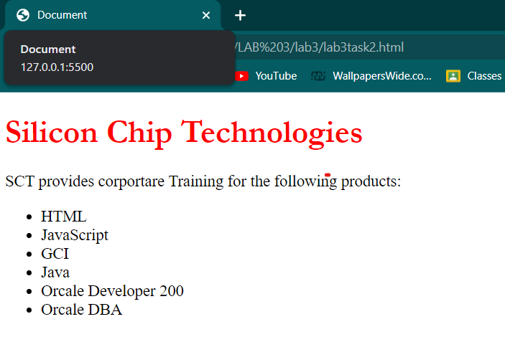

Figure 3.9 – Task 2 output

---------------------------Task 3.3---------------------------

Write the HTML code along with CSS file that generates the output web page shown in Figure 3.9.

**HTML CODE:**

</body>

</html><!DOCTYPE html>

<html lang="en">

<head>

    <meta charset="UTF-8">

    <meta http-equiv="X-UA-Compatible" content="IE=edge">

    <meta name="viewport" content="width=device-width, initial-scale=1.0">

    <link rel="stylesheet" href="task3.css">

    <title>Working with Style sheets</title>

</head>

<body>

    <h1 > Silicon chip technologies</h1>

    <P>SCT provides corprates training of the foloowing products </P>

    <ul>

        <li>HTML</li>

        <li>Javascript</li>

        <li>SGI</li>

        <li>JAVA</li>

        <li>Oracle developer 2000</li>

        <li>Oracle DBA</li>

    </ul>

</body>

</html>

**CSS FILE:**

h1{

    color: red;

    size: 26pts;

    font-family: Garamond;

    margin-top: 5%;

}

---------------------------Task 3.4---------------------------

Rewrite Example 5 using ID Selector instead of class Selector and show its output.

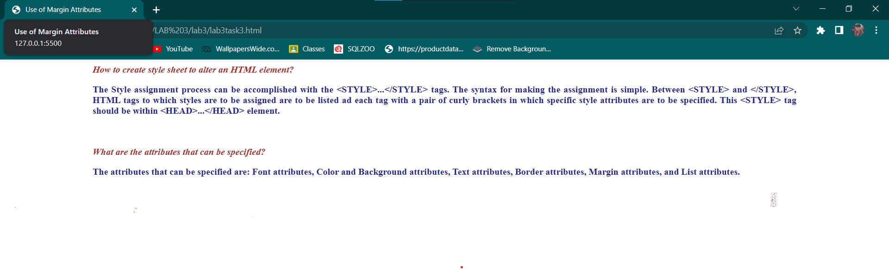

# ---------------------------Task 3.5---------------------------

Bootstrap 5.2.3 Examples:

Go through the following examples in bootstrap-5.2.3-examples.zip file provided with Lab 01: sign-in, cover, checkout, and blog. Modify these examples for a real-world application. Submit the modified web pages and respective HTML and CSS files with description.

**Sign-up:**

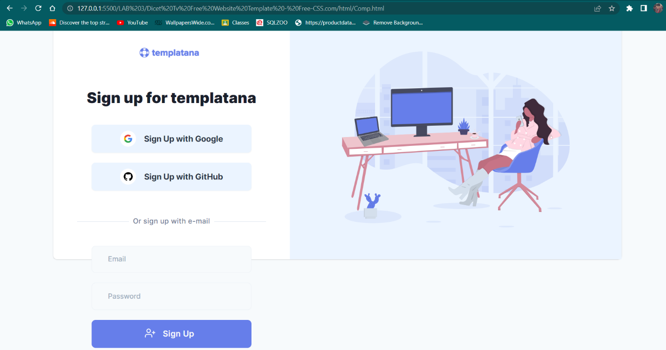

**Checkout:**

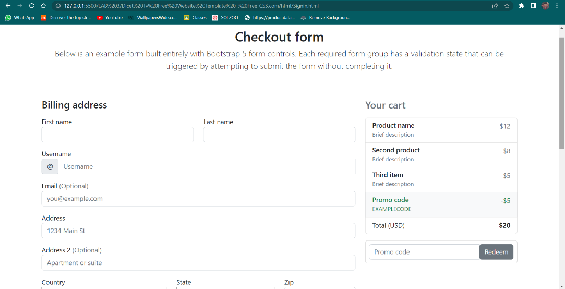

**Blog:**

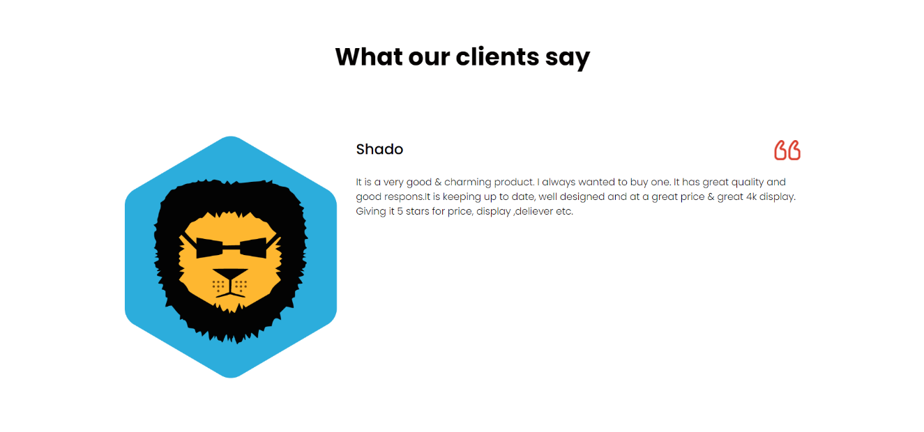

**Main Page:**

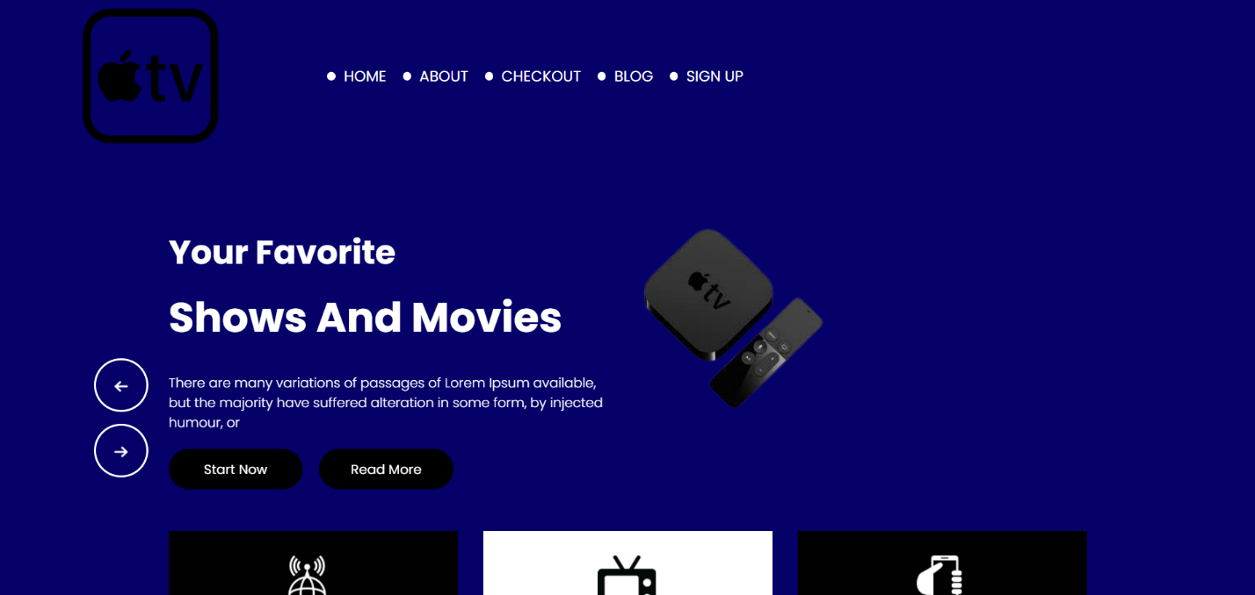

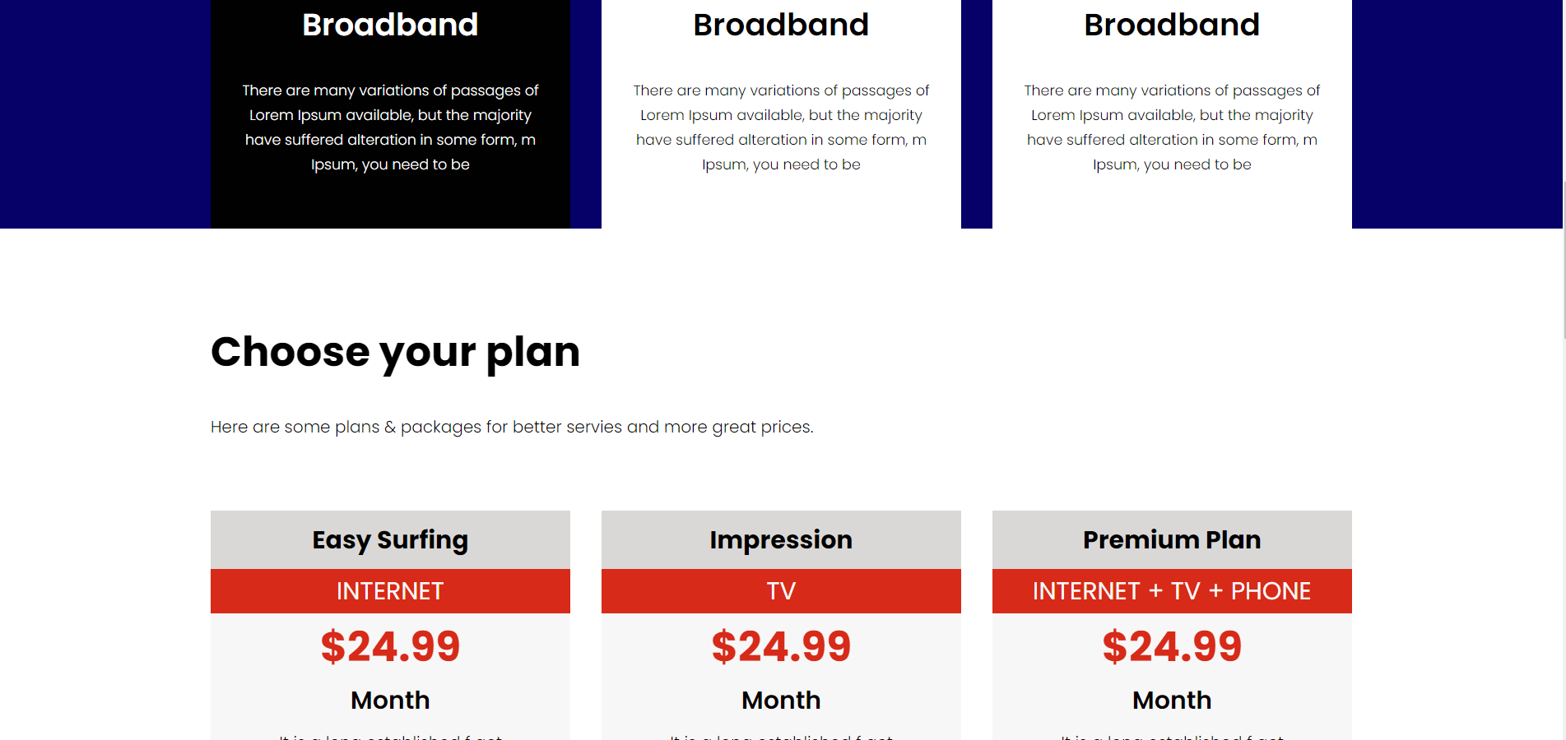

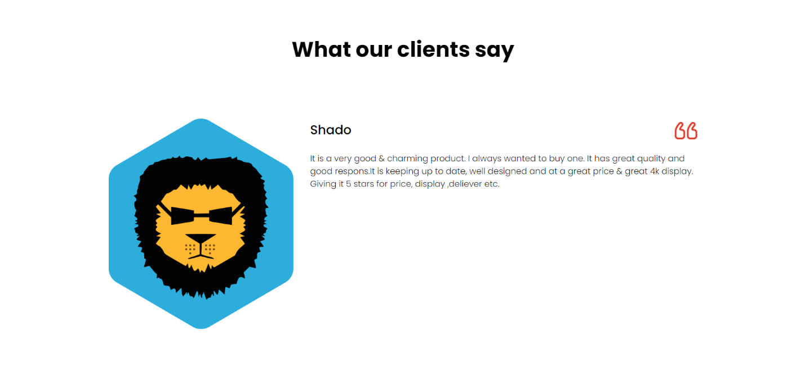

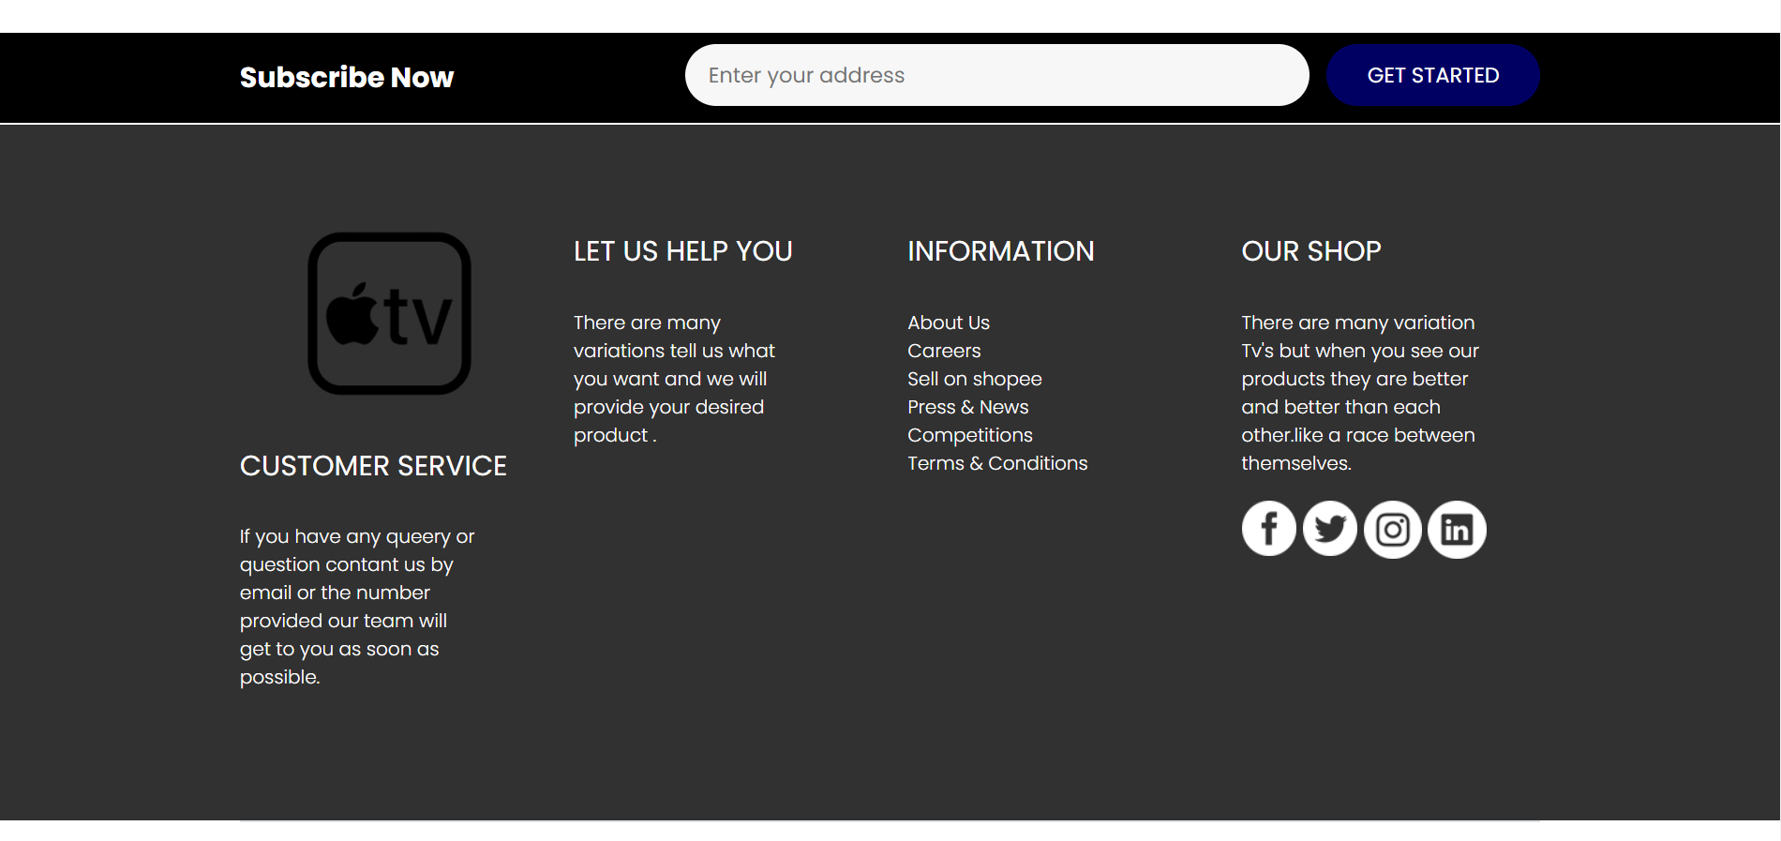

# ---------------------------Task 3.6---------------------------

Modify your CV designed using plain HTML in last lab by adding CSS and Bootstrap in it. Upload both original one and modified one on the hosting site. Provide the link.

**Original CV:**

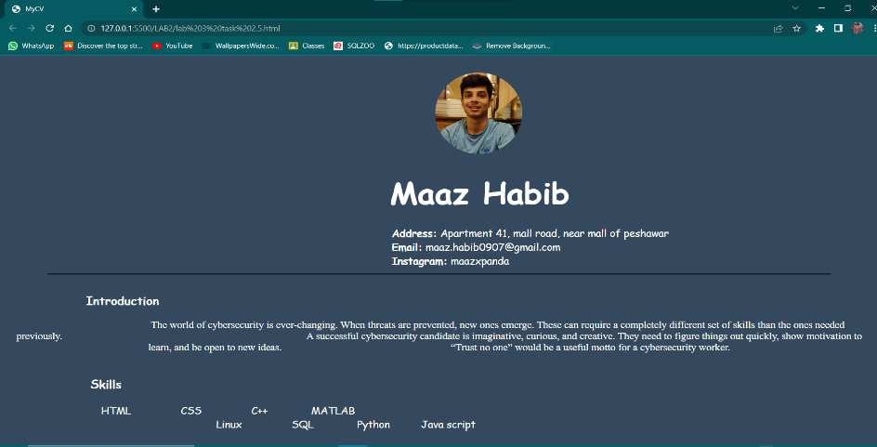

**Modified CV:**

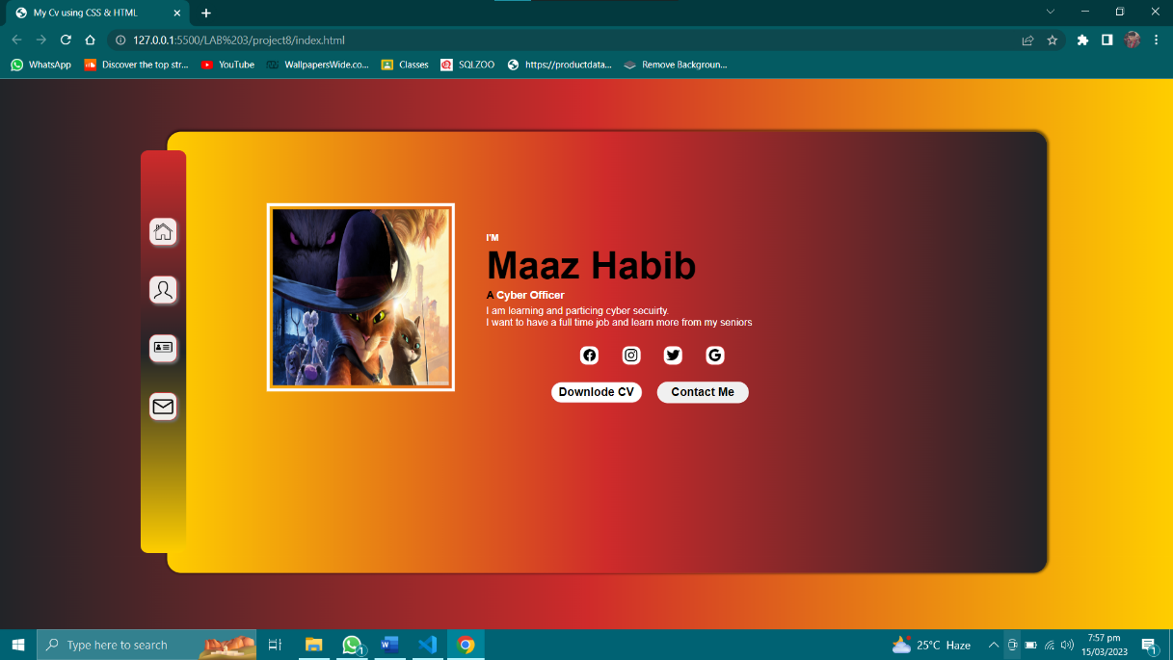

# ---------------------------The end---------------------------